Name: Saniya Galib Tamboli

Email: [saniyagtamboli2412@gmail.com](mailto:saniyagtamboli2412@gmail.com)

Batch: DWS_B5_25VID2550

User Id: 34749

Date: 08/08/2025

ASSIGNMENT

* Cmdlets are the basic, lightweight commands in the Windows PowerShell environment. They are designed to work in conjunction with the pipeline, processing objects as input and outputting objects.
* Cmdlets are named using a "Verb-Noun" format, where the verb represents the action and the noun represents the object of that action.

**Common Verbs:**

1. Get: Retrieve information
2. Set: Change a value
3. New: Create a new instance
4. Remove: Delete something

**Commands**

1. **Get-Process**: This Cmdlet retrieves a list of all currently running processes on your machine.

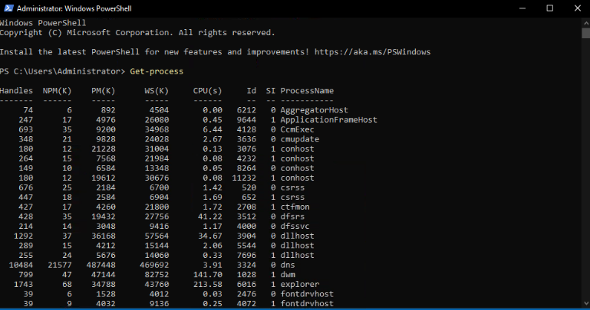

Fig.1. Get-Process

* Get-Process -Name “explorer”

In this case, the -Name parameter is used to filter the results to only show processes named “explorer”.

* Get-Process | Where-Object { $_.CPU -gt 100 } | Sort-Object -Property CPU –Descending :

This command retrieves all processes, filters those using more than 100 CPU seconds, and sorts them in descending order based on CPU usage.

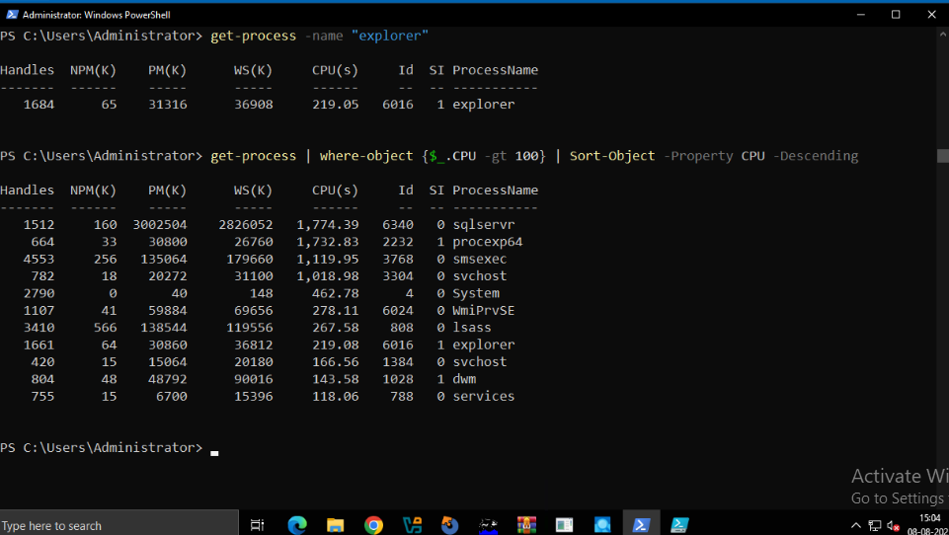

Fig.2 Get-Process with Parameters and Pipelining

1. **Get-Command:** It lists all the commands (cmdlets, functions, scripts, and even external programs) available in your session.

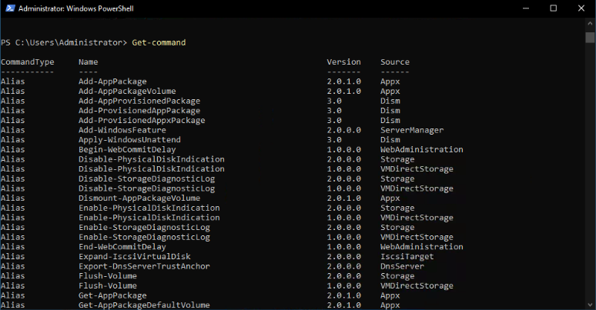

Fig.3 Get-Command

1. **Set-Date:** lets you change the system date and time

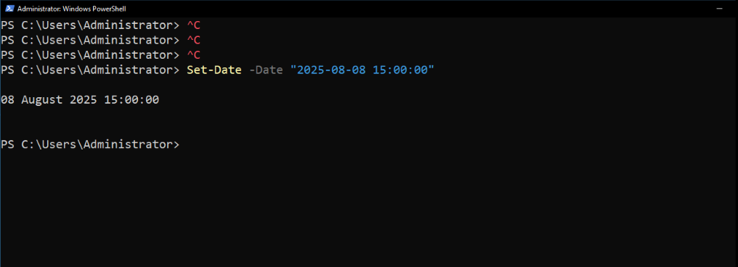

Fig.4. Set-Date

1. **Get-Service:** Retrieves the status of services on a machine.
2. **Stop-Service:** Stops a specified service.
3. **Start-Service:** Starts a specified service.

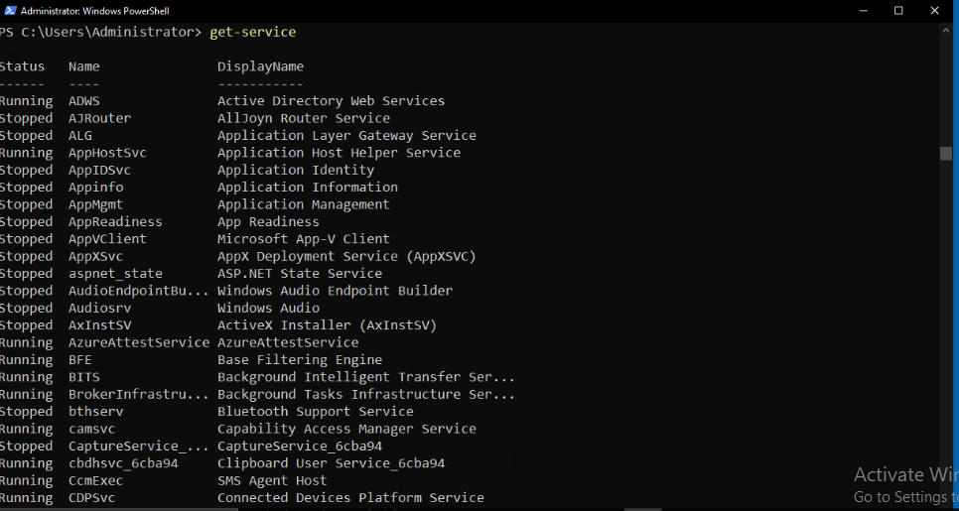

Fig.5 Get-Service

1. **Get-EventLog:** Retrieves entries from event logs.

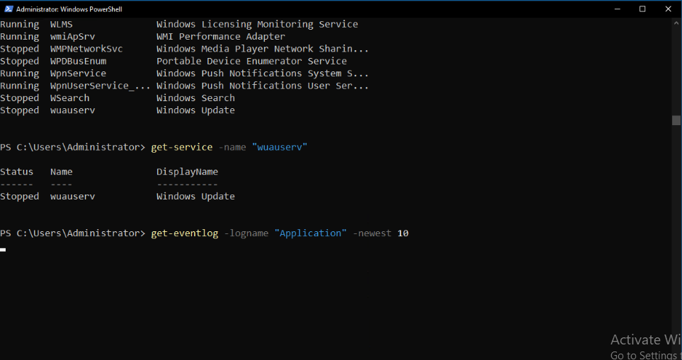

Fig.6 Get-Service with Parameters and Get-EventLog